
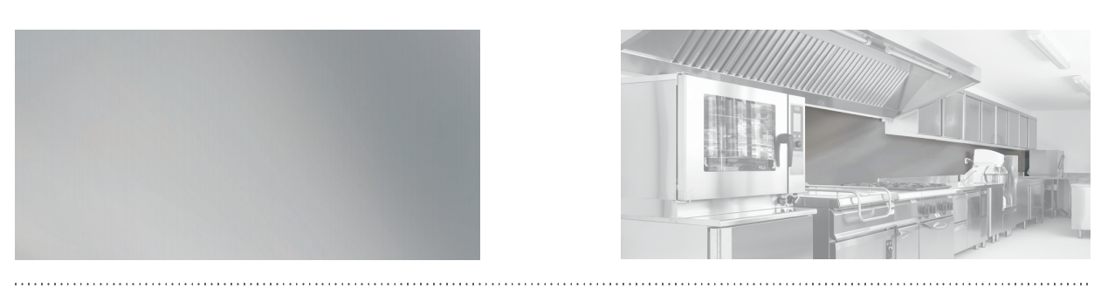

SPECIFICATION

PLAC’INOX
BRUSHED STAINLESS STEEL PROTECTION PLATE
- Description: protection plate (Plac’Inox as manufactured by SPM) 10/10th mm thick in brushed stainless steel approved for food handling areas. Its maximum length is 2.50 m and its maximum height 1.25 m.
- Finish: brushed metal.
- Installation method: glue as per manufacturer’s instructions.
